Final Lab: Unlock Your Mind!
Susmita Poudel

Purpose

For the final project, we are given the task to unlock a Lock, a cryptographic hash, that opens with a sequence of actions generated based on the string passed in creating the lock. We are implementing three different search algorithms: Breadth-First Search, Depth-Limited Search, and Iterative Deepening Search to unlock the lock. We are testing these algorithms on locks ranging from length 1 to 14 and recording the amount of time and space for each of them to run. With this observation, we compare and contrast the efficiency and effectiveness of the three algorithms.

Overview

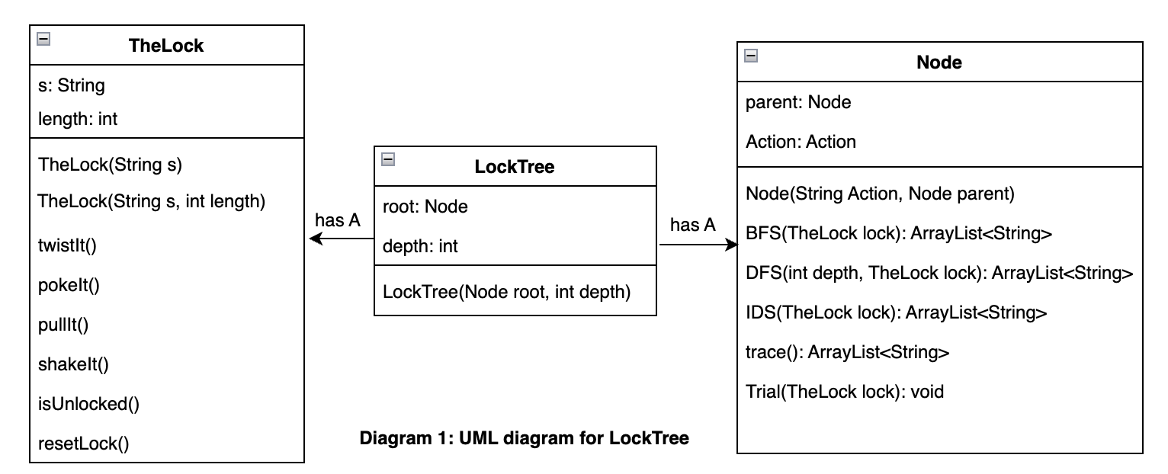

There are four actions that can be applied to the lock: pull, poke, shake and twist, and each lock can be unlocked with a unique sequence of these actions. Each of these actions can be represented with a Node object. Hence, a tree structure where every node has four children is used to solve this problem. The actions are stored as string values from 1 to 4, and the root of the tree holds our lock stored as “lock”. The LockTree has a Node and TheLock. The trace() method traverses from the node at a certain depth upto the root of the tree to return an ArrayList of the sequence of actions(the node value of the root is not included in the arraylist). It utilizes the parent attribute for the traversal to get the path. The Trial method calls the trace method to get the sequence of actions and calls the method corresponding to that action to the lock. For instance, if we specified “4” to represent shake, then the trial method will call shakeIt() method to the lock whenever there is “4” in the sequence of actions.

Details

We use a 4-ary tree structure to hold the sequence of actions. However, we do not start by creating the tree with all possible nodes. In fact, we only create the root of the tree. The stack/queue structure are utilized to store the nodes visited, attempt to unlock the lock, and generate children. We use Java’s built-in linked list structure instead of building our own stack and queue. The following sections discusses the details of the three algorithms in unlocking the lock.

- Breadth-First Search (BFS) Algorithm:
The BFS algorithm utilizes queue structure (FIFO) to find the solution sequence. We utilize java’s built-in linked list structure where we can add and remove nodes for this algorithm. The BFS checks all the nodes within the same tree level to find the solution from left to right order. If it does not find the solution at that tree level, it moves to the next level and searches all the nodes in that level. This algorithm adds the new node into the queue, removes the oldest node from queue and checks if the sequence of actions represented by the path from removed node to the root unlocks the lock. If it does not, it proceeds to generate children for the removed node and add those children to the queue. Then, it moves on and repeats the same process for every node in the queue until it finds the solution.

Diagram 2 depicts the changes in the tree and queue with BFS algorithm. The white circled nodes represent the nodes that have been removed from the queue. In Diagram 2, we start our tree with just the root Node and add that to the queue. We remove this node from the queue. Then proceed to check if it unlocks the lock. Since it does not, we add four children to that node and push those children into our queue. Then we remove the oldest node from the queue, and repeat the same process until we find the sequence that unlocks the door.
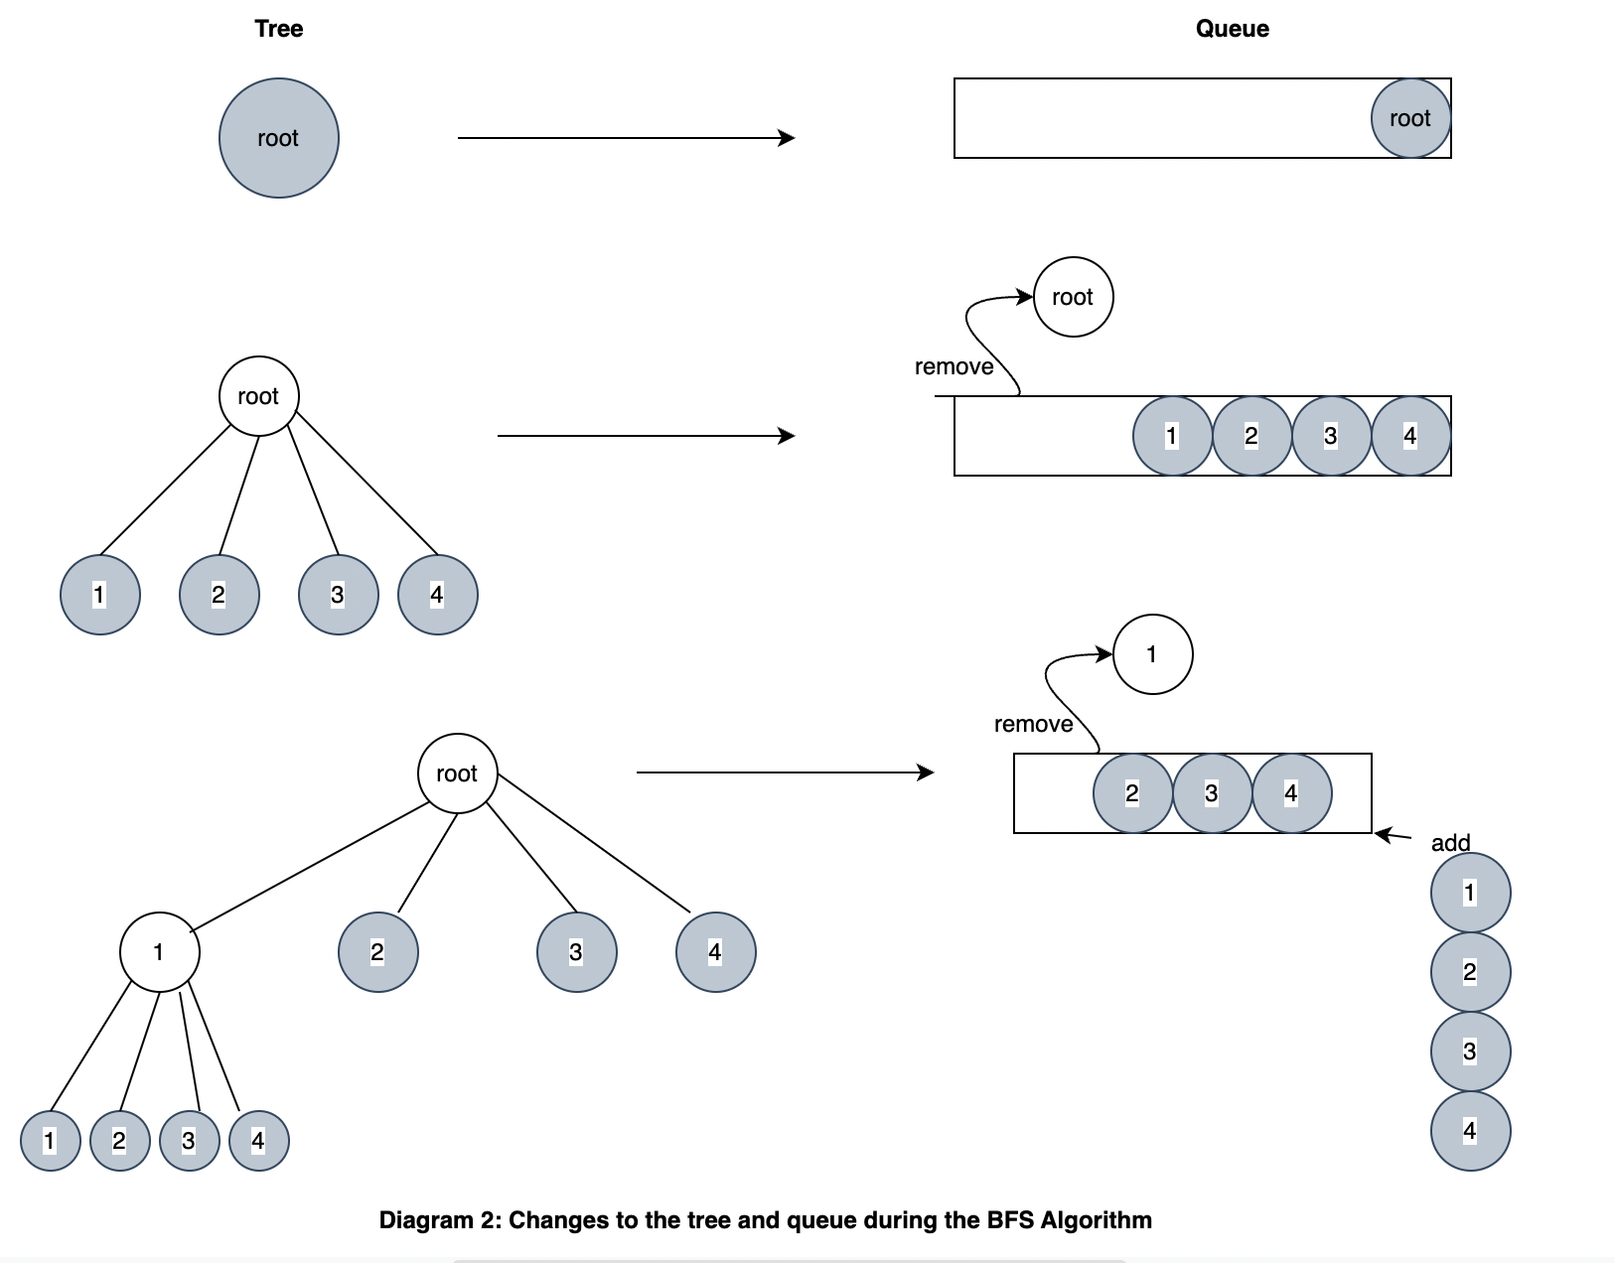

2) Depth-Limited Search (DLS) Algorithm
The DLS Algorithm utilizes the stack (FIFO) structure to check the nodes to find the solution sequence. We use Java’s built-in linked list structure where we can pop and push objects. For DLS, we need to specify the length of the solution that opens our lock. The DLS Algorithm will go deep down the tree as far as possible to find the correct solution. We will add children for every popped node and push them onto the stack until the depth limit is reached.

Diagram 3 depicts the tree and stack during the first few stages of DLS algorithm. The white circled nodes represent the nodes that are popped out of the stack. Suppose, our solution has a depth of 2. We start with a tree with just root and push that onto our stack. Then we pop the root from the stack and add 4 children and push them onto the stack. Then, we pop the last added node (Node 4 in our case) and add children and push them onto the stack. We check to see if the lock is unlocked by the sequence. If the lock is unlocked, we pop another node from the stack and check with the help of trial method if it unlocks the lock. Then, we repeat this process until we find our solution sequence.
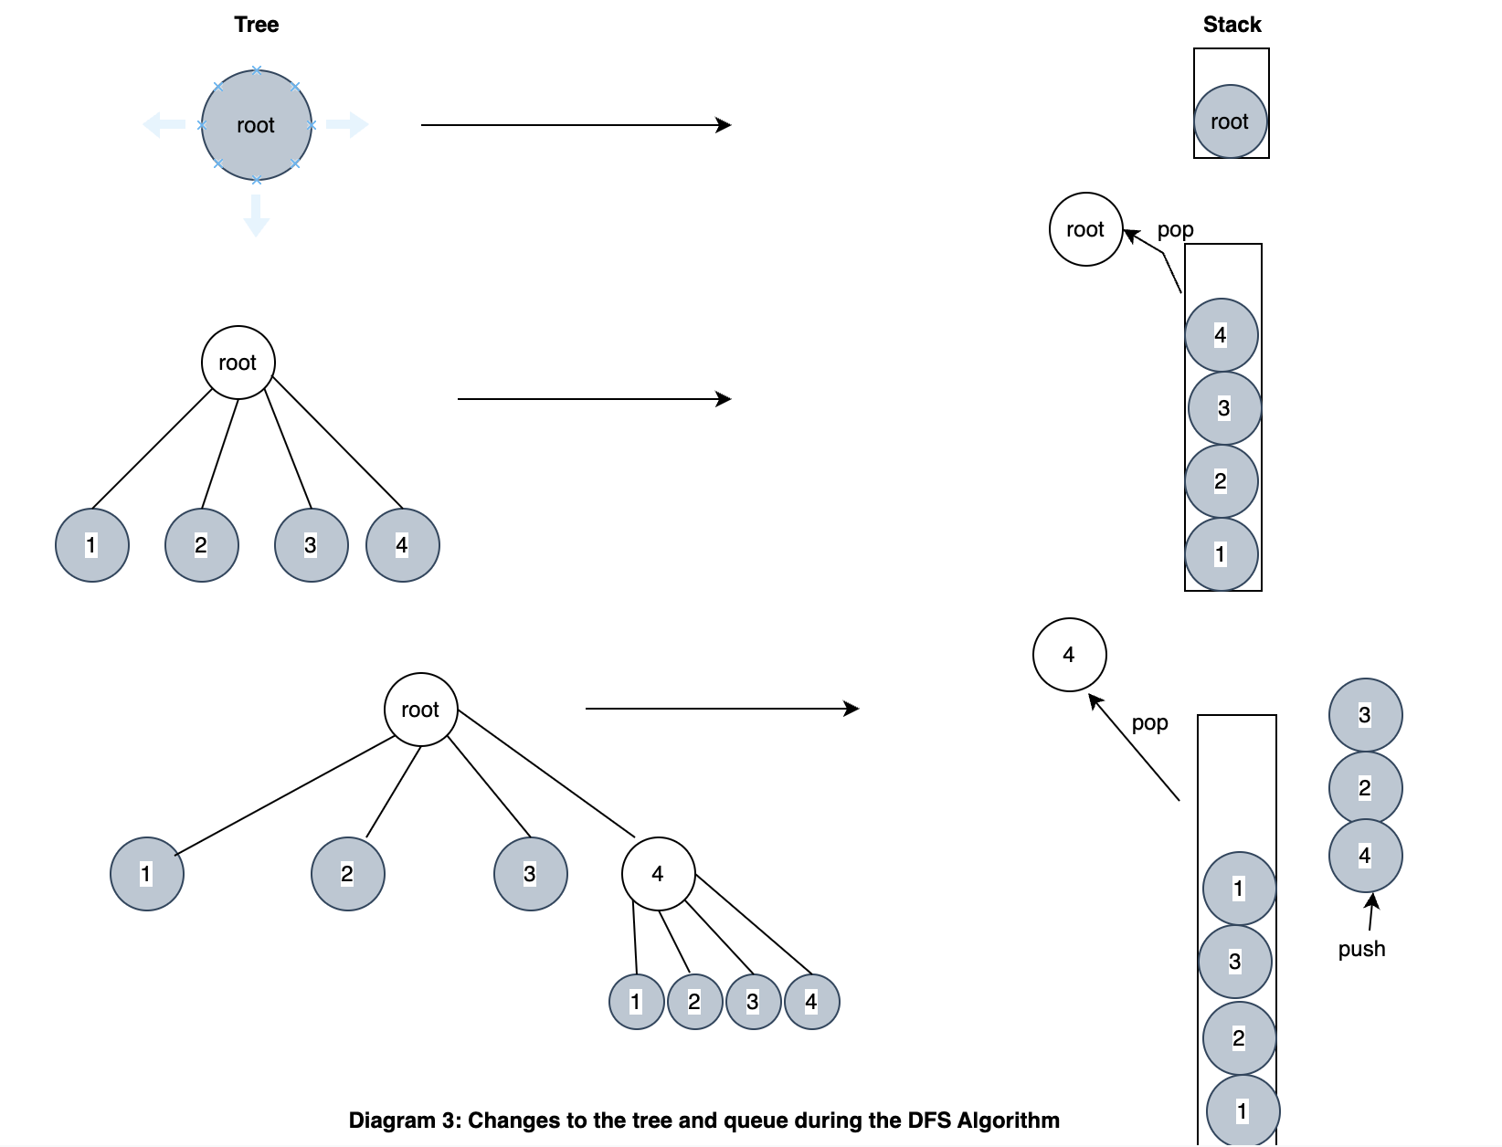

3. Iterative Deepening Search (IDS) Algorithm
IDS is very similar to DLS Algorithm in the way they work. However, the main difference is that IDS does not have a depth limit at which the tree would stop expanding. Therefore, we implement the IDS with the help of DLS algorithm by increasing the depth with iteration to find the solution.

Pseudocode for IDS Algorithm

Initialize depth to 0;
While lock is not unlocked
Call IDS at depth;
Increase depth by 1;
Return IDS at solution depth

Test results and Analysis

We tested all three algorithms on the same lock, with length from 1 to 14. For each length, we created five different locks and recorded the total nodes visited, length of stack/queue when the solution was found, and the running time. We used the data to calculate the average for each algorithm and presented the final results in the Diagram 4 below.

Lock  Length | BFS Algorithm |  |  | DLS Algorithm |  |  | IDS Algorithm
 | Mean  (nodes  visited) | Mean  (Queue length) | Mean  (time in ms) | Mean  (nodes  visited) | Mean  (Stack length) | Mean  (time in ms) | Mean  (nodes  visited) | Mean  (Stack length) | Mean  (time in ms)
1 | 3.8 | 8.4 | 0 | 3.2 | 1.8 | 0 | 3.8 | 1.8 | 0
2 | 12.8 | 35.4 | 0 | 12.8 | 2.6 | 0 | 17.8 | 2.6 | 0.4
3 | 72.4 | 214.2 | 0.4 | 19.8 | 6 | 0.2 | 40.8 | 6 | 0.6
4 | 214.6 | 640.8 | 0.6 | 172 | 7.4 | 0.6 | 257 | 7.4 | 0.8
5 | 728.6 | 2182.8 | 0.8 | 852.6 | 9.2 | 1.2 | 1193.6 | 9.2 | 1.4
6 | 2791.2 | 8370.6 | 3 | 3563.8 | 9.2 | 3 | 4928.8 | 9.2 | 5.2
7 | 10978 | 32931 | 10.2 | 14497.2 | 9.8 | 9.8 | 19954.6 | 9.8 | 12.8
8 | 27337 | 82002 | 19 | 80062.4 | 8.2 | 30.8 | 102028.6 | 8.2 | 40.6
9 | 92867.8 | 278600.4 | 54.4 | 342213.2 | 7.8 | 113.8 | 429594.2 | 7.8 | 157.6
10 | 1259923 | 3779766 | 1104.2 | 184244.2 | 17.6 | 77.8 | 533769.2 | 17.6 | 181.2
11 | 5454227.4 | 16362679.2 | 5156.2 | 184244.6 | 20.4 | 81.6 | 1581605.6 | 20.4 | 786.6
12 | 22231444.4 | 66694330.2 | 26317.6 | 184244.4 | 23.8 | 86.6 | 5776649.4 | 23.8 | 3361.4
13 | * | * | * | 44923486.8 | 24.6 | 22012.8 | 67293107.8 | 24.6 | 39326.6
14 | * | * | * | 44923488.2 | 28 | 22022.4 | 134401973.2 | 28 | 89580.2

The asterisk (*) on the table represents that there was not enough memory space to run the algorithm on the corresponding lock length.
The bolded data shows an unusual pattern in the overall dataset.

Diagram 4: Table of data( nodes visited, running time, stack/queue size remaining) for BFS,DLS, and IDS for 14 different locks

From the results in Diagram 4, we can interpret and draw the following conclusions about these three algorithms:
- For locks with relatively shorter length( 1 to 6), the average running time for BFS and DLS is not significantly different. IDS has the longest average running time for these lengths. Diagram 5 shows the line graph of running time for BFS, IDS, and DLS from length 1 to 6.

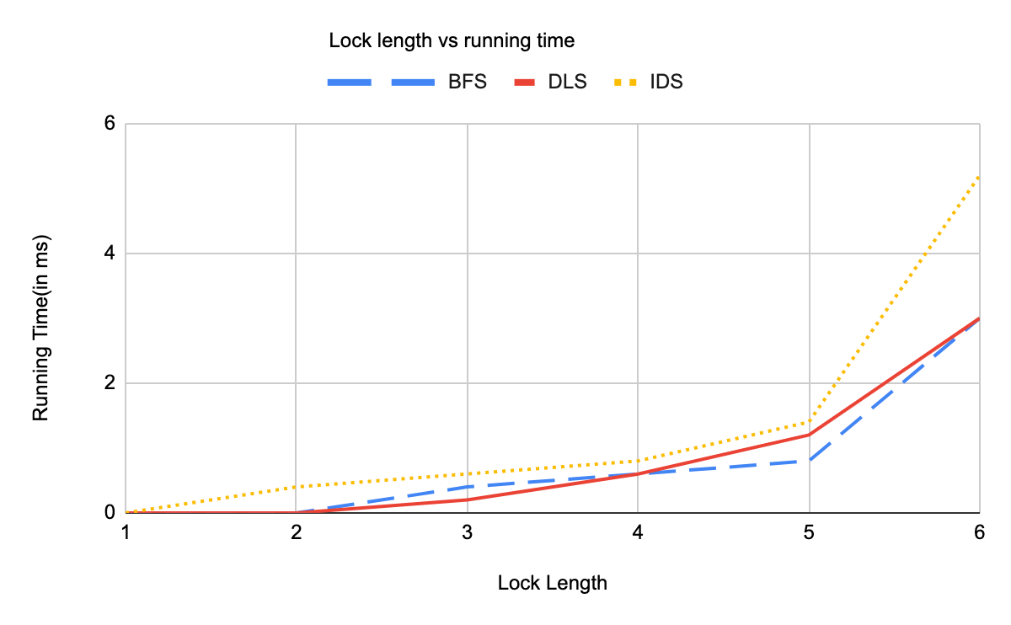
Diagram 5: Graph of lock length vs running time for BFS, IDS, and DLS.

2)The queue length for BFS increases rapidly especially after length 3 in comparison to the stack length in IDS and DLS. This is an expected pattern because BFS needs to store all the nodes within a depth level of the tree in the queue. In fact, the BFS algorithm crashed at around length 13 because the nodes that are stored in the queue exceeds the available memory space. However, DLS and IDS algorithms do not require much memory space as BFS, and hence can successfully run at any given length.

3) The BFS algorithm also crashes when trying to run a lock with unknown length because of lack of memory space to hold the extremely huge queue size. However, IDS successfully ran to get the solution for the unknown lock length. The results are summarized in Diagram 6, and we also found out that the lock length was 16 after running the code for our cryptographic hash.
 | Nodes visited | Stack/Queue length | Running time(in ms)
BFS | * | * | *
IDS | 1431655765 | 22 | 4048234

The asterisk (*) on the table represents that there was not enough memory space to run the algorithm on the corresponding lock length.
Diagram 6: Table for BFS and IDS algorithm on a lock of unknown length

4) We also observed that IDS algorithm has longer running time than DLS algorithm from our table. This is an expected observation because IDS algorithm runs from length 0 until the solution depth iteratively so it records the all the running time, whereas DLS algorithm only runs for the given depth so it only records the running time of a particular length as demonstrated in Diagram 7.

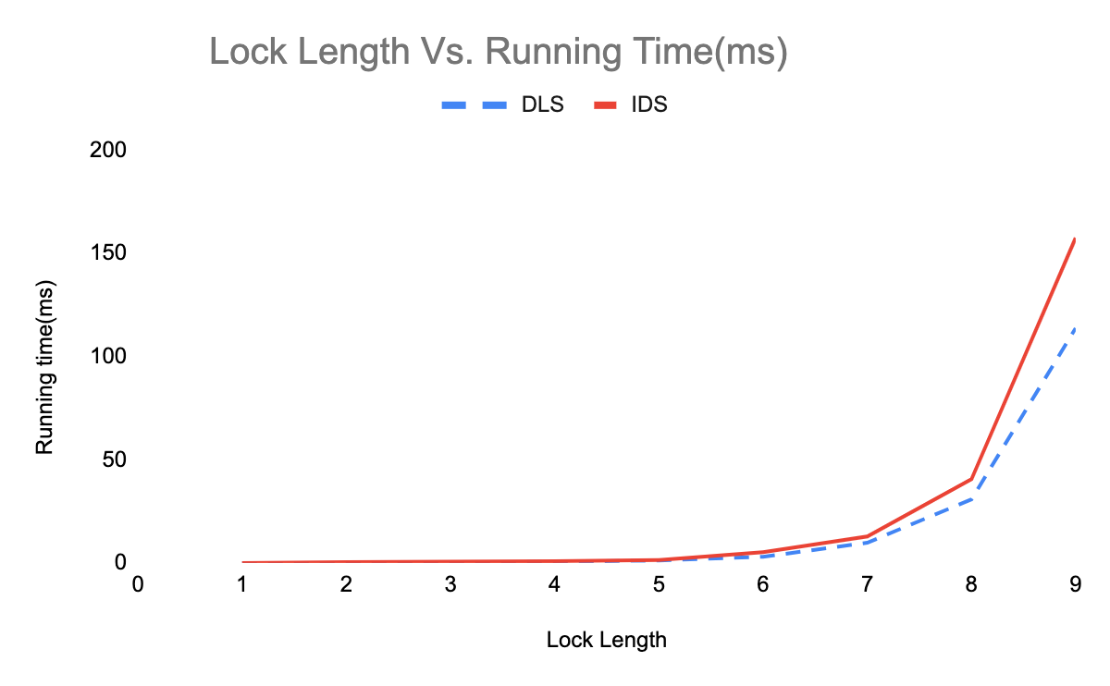Diagram 7: Line graph demonstrating the running time for DLS & IDS for lock length of 0 to 9

5) For DLS Algorithm, my running time for length 9 is much larger than my running time for lock of lengths 1-8 and 10-14. This can be seen as bolded in Diagram 4. I expected the running time to increase as the length of lock increases, for length of 9 it does not follow this expected pattern. This is because we are utilizing a cryptographic hash to create a solution,but hash functions are not universal. Hence, the observed data for my lock does not follow the expected pattern. The longer running time is explained by the higher number of nodes visited at length 9 to find the solution.

From our tests, we can conclude that IDS and DLS algorithms are better to use when we know that our solution is farther from the start point. On the other hand, BFS algorithm works well when our solution is closer to the root. DLS is effective especially because its average running time is much less than that of IDS and BFS. Both IDS and DLS algorithms take much less memory space than BFS algorithm. However, if we do not know the length of our solution, IDS is ideal algorithm to find the solution.

Areas of improvement: The test results could be more accurate representation of the trends in our algorithms if the testing size were increased. Currently, we performed the testing on five locks. However, for real world, that sample size is pretty small, and hence we could improve the accuracy of our results to support our interpretation.

